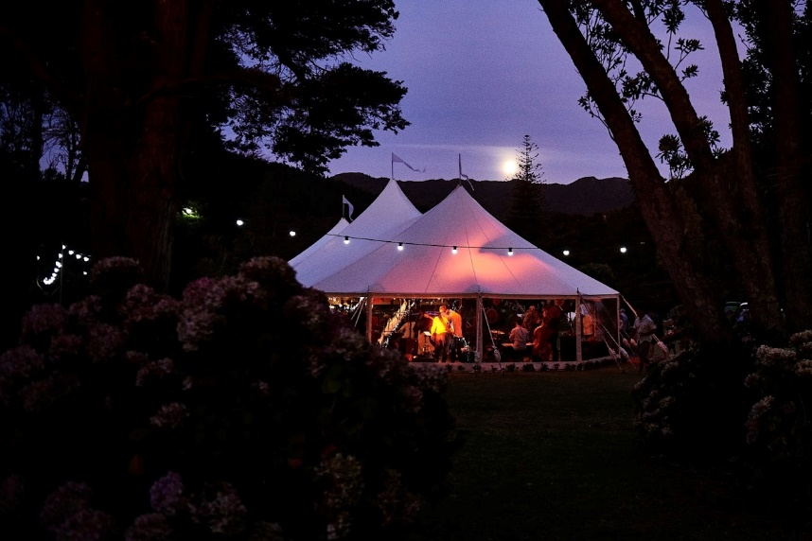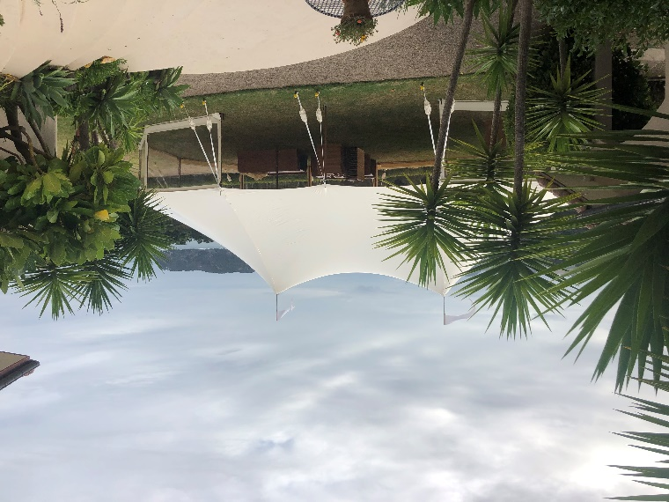

**The Package**

The dream 160 Hampton Marquee package includes the following:

* A 21.2mtr x 9.7mtr diameter Hampton erected on grass.
* 21 x 2.4mtr trestle tables (your choice vintage wooden or standard with white linen cloth).
* 160 premium padded chairs (your choice of wooden folding or white resin folding chairs).
* Marquee lighting package (includes festoon & fairy lights).

Delivery and Pick up to site, erect tent, set up lighting, stack tables and chairs and pack down after the event.

3 day hire within 65 km driving distance of Whitianga

**Usual price $8,050.00 incl GST.**

**Total Package Price of $7,245.00 incl GST.**

*No allowance for consent fee if required.*

**Great Savings!**

**Hampton Marquee Wedding Package - 160 Guests**

Lets’ face it – planning a wedding can be stressful so we’ve created a simple and cost-effective package solution for a wedding with up to 160 guests, to help you get the basics sorted.

We deliver to site, erect your Hampton Marquee, set up lighting, stack your tables and chairs inside the marquee and come back to pack down after your event. This package is based on a three day hire and includes delivery within 65km driving distance of Whitianga.