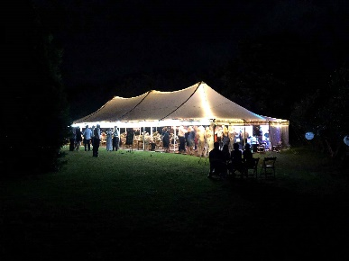

**The Package**

The dream 80 Electron Marquee package includes the following:

* A generous sized 12mtr x 9mtr Electron Marquee with a combination of clear and white sides, installed on grass. Loads of room to circulate, space for a dance floor etc.
* Silk line ceiling liner.
* 11 x 2.4mtr trestle tables (your choice vintage wooden or standard with white linen cloth).
* 80 premium padded chairs (your choice of wooden folding or white resin folding chairs).
* Marquee lighting package (includes festoon lighting & fairy lights).

Delivery and Pick up to site, erect tent, set up lighting, stack tables and chairs and pack down after the event.

3 day hire within 65 km driving distance of Whitianga

**Usual price $4,646.00 incl GST.**

**Total Package Price of $4,181.00 incl GST.**

*No allowance for consent fee if required.*

**Great Savings!**

**Upgrade**

Need more space for dance floor, band, lounge furniture etc? – No Problem! - we will upgrade to:

15mtr x 9mtr Electron Marquee for an additional $600.00

We also hire an extensive range of wedding and event related items that you may need, including bars, bar caravan, crockery, cutlery, glassware, heating, PA Systems, dance floors, special effects lighting, linen and much more.

**Electron Marquee Wedding Package - 80 Guests**

Lets’ face it – planning a wedding can be stressful so we’ve created a simple and cost-effective package solution for a wedding with up to 80 guests, to help you get the basics sorted.

We deliver to site, erect your Electron Marquee, set up lighting, stack your tables and chairs inside the marquee and come back to pack down after your event. This package is based on a three day hire and includes delivery within 65km driving distance of Whitianga.