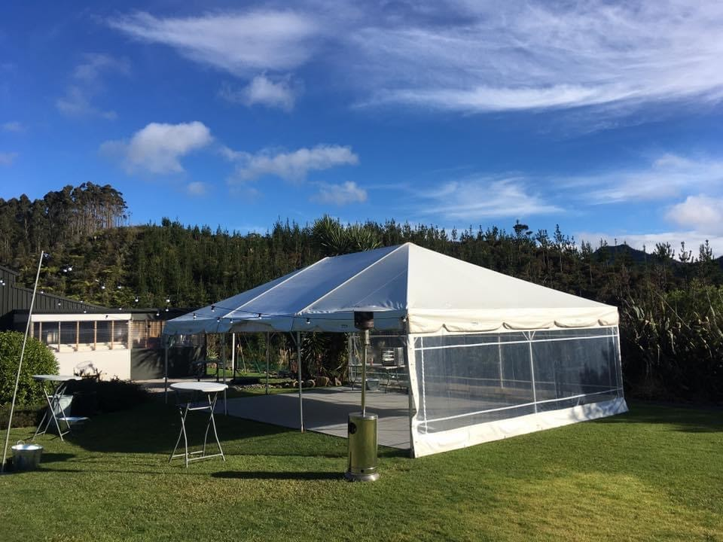
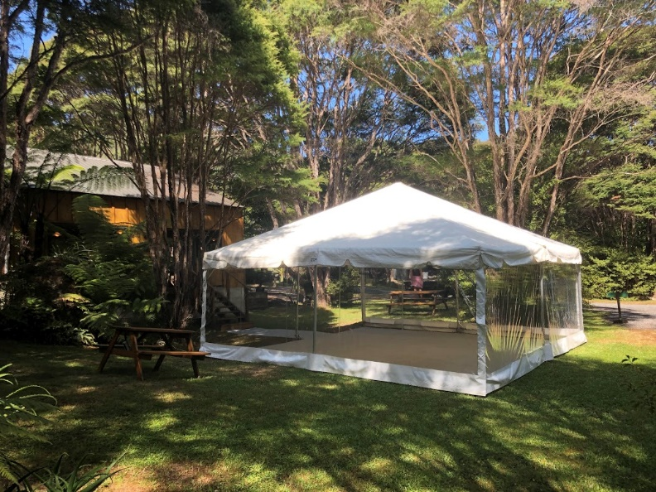

The Package
The Party Package includes the following:
-6mtr x 6mtr Clipframe (no liner)
- Your choice of fairy lights or standard festoon - Installed
-Bar Leaners x 4
*price excludes delivery charge

Usual price $1000 incl GST
Total Package Price of $600 incl GST

Great Savings!
Upgrade
Do you want your party to have a bit more dazzle? No problem, we also hire an extensive range of party hire items that you may need, including bars, bar caravan, crockery, cutlery, glassware, heating, PA systems, dancefloors, special effects lighting, linen and much more that will make you party one to remember.

We will add the following hire items to your package for an additional $500 incl GST
-Dancefloor – your choice of whitewash/charcoal/mahogany
-2 x light stands
-30m of standard festoon for outdoor lighting
-12” PA system
Party Package
Planning a party? We have put together a party package for those smaller events this summer season. Just the basics to get you started, check out our website for anything else you might need.

