
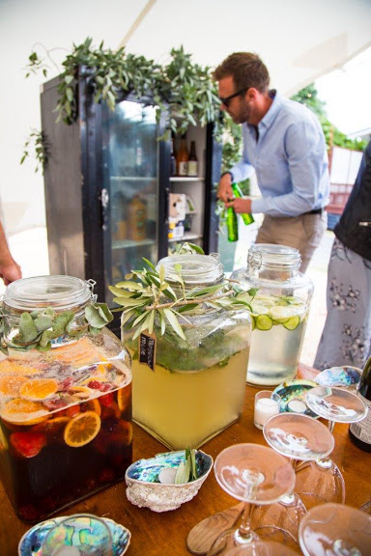
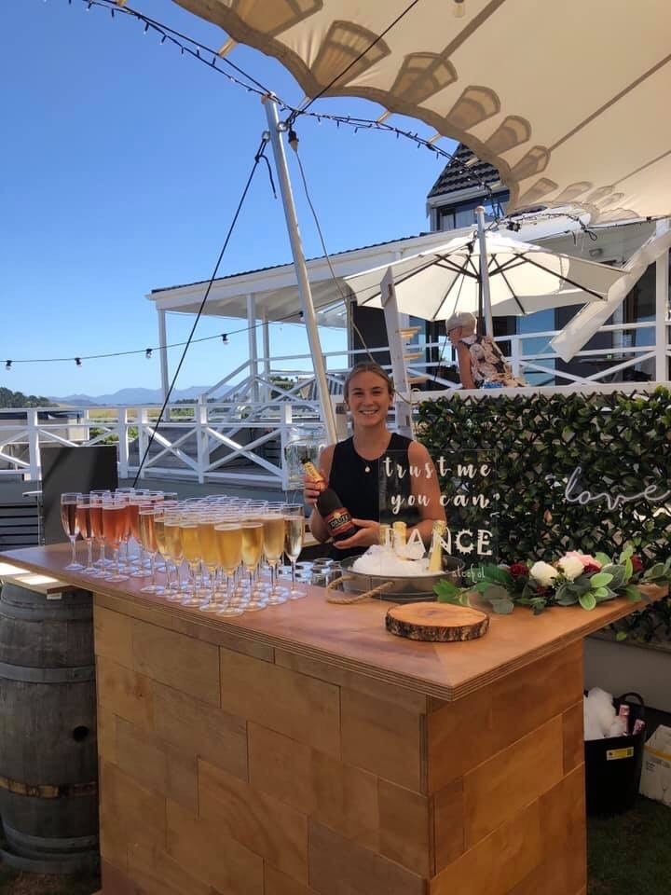
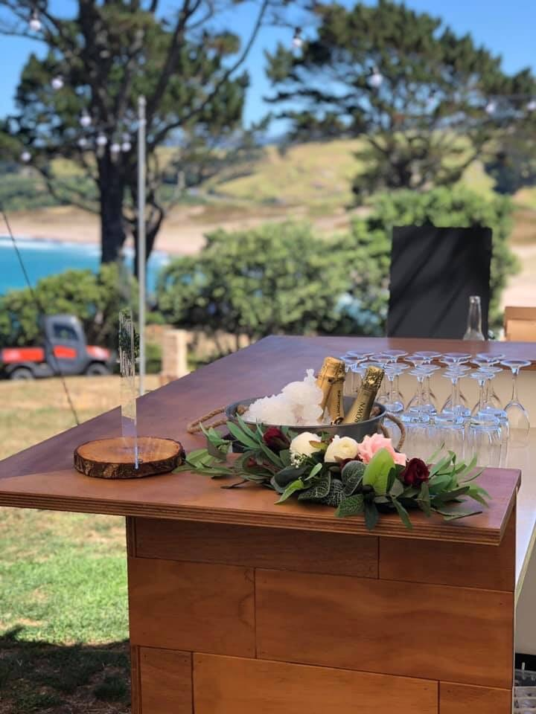

Bar Package - 100 People
Lets’ face it – planning a wedding can be stressful so we have created a simple and cost-effective package solution for a wedding with up to 100 guests, to help you get the basics sorted.
The Bar Package is designed for a celebration event with 100 guests and is priced at $520.00 incl GST.

Customise the package
Need to customise the package for your particular event? No problem! - contact us and we’ll work together to create a package specially for you.
Usual price $578.00 incl GST.
Package Price $520.00 incl GST

Great savings!

The Bar Package
The bar package includes the following:
• Timber static bar
• Refrigerated Chiller
• 80 x 230ml wine glasses
• 50 x Hi ball glasses
• 50 x water glasses
• 4 x ice bins
• 1 x punchbowl and ladle
• 2 x 6ltr water dispensers
Great Savings!

