
https://millcreekcottage.co.nz/
https://peninsulapartyhire.co.nz/
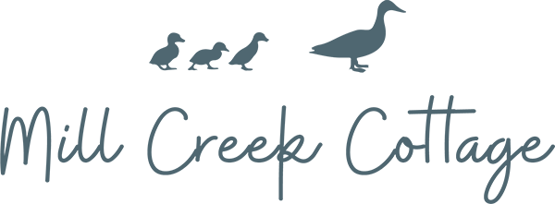

FARMSTAY & WEDDING VENUe package – 100 Guests
Lets’ face it – planning a wedding can be stressful so we have created a simple and cost-effective package solution for a wedding with up to 100 guests, to help you get the basics sorted.
A picturesque rural setting where we can help you create the perfect stress-free wedding. Hire the cottage and the wedding paddock, Peninsula Party Hire will erect the marquee of your choice. You can have a full wedding package provided by professionals.

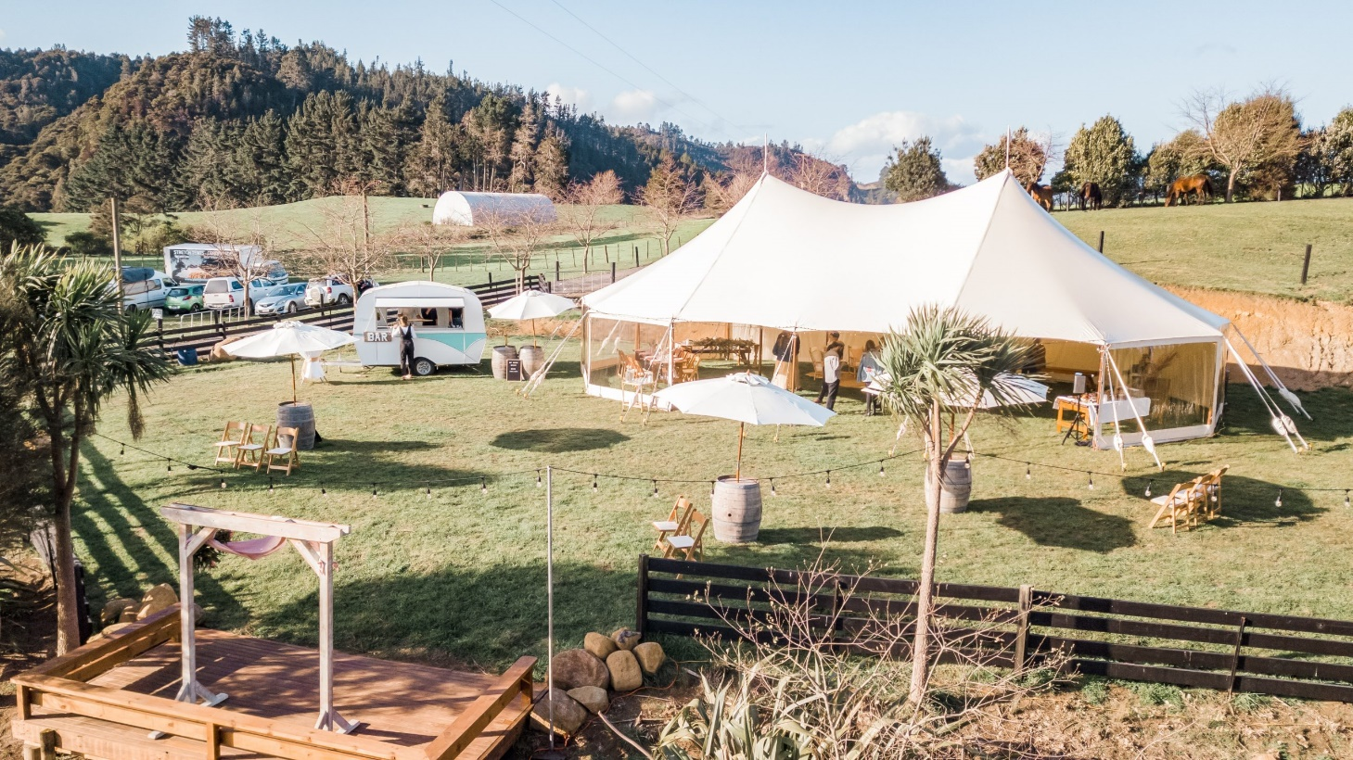
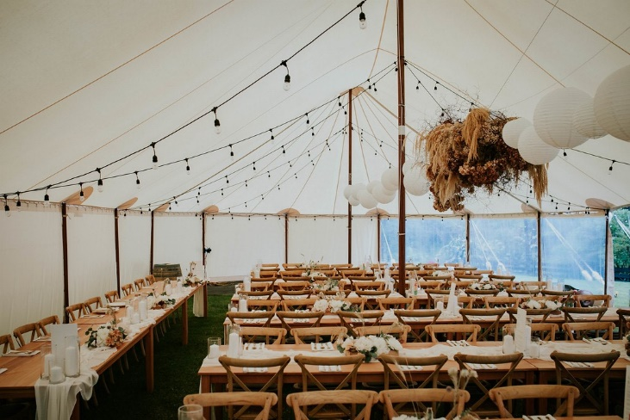
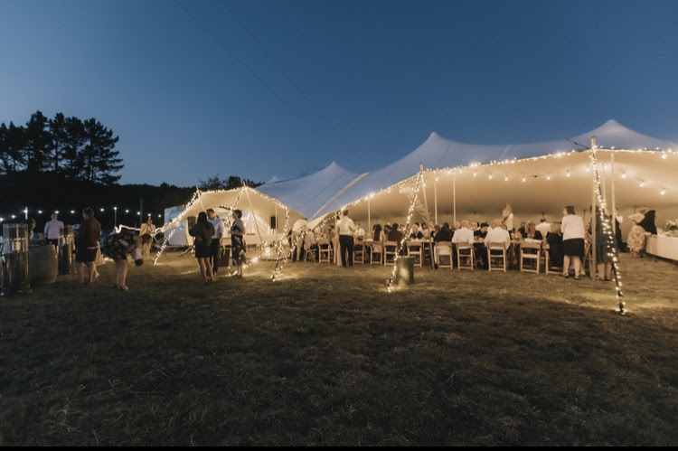
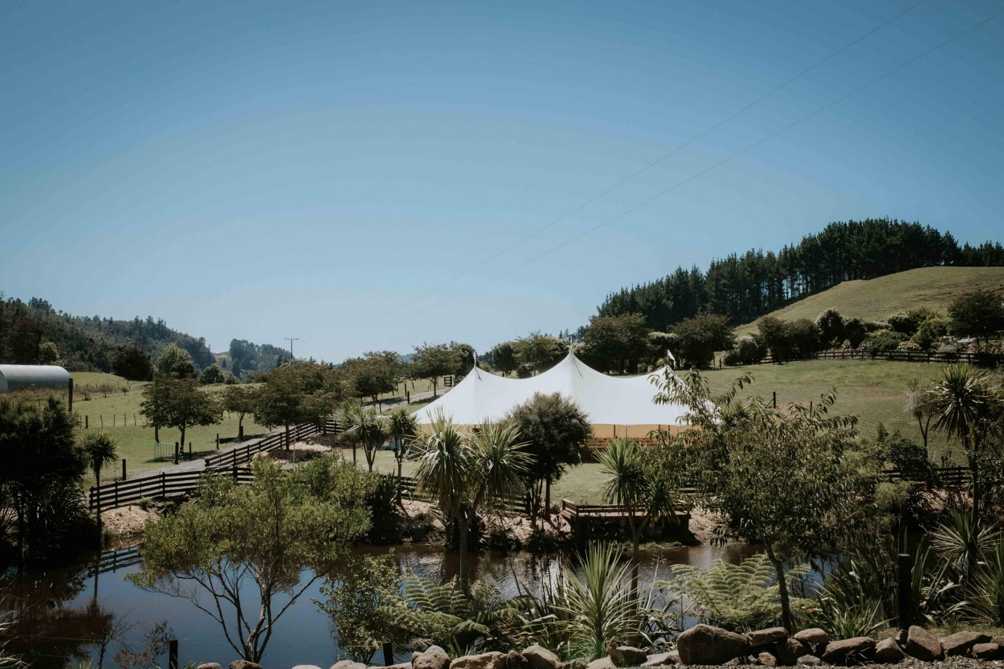
Prefer our Hampton Marquee or Electron Marquee over the Stretch Tent?
No Problem! - You can change to a 15mtr x 9mtr Electron Marquee (incl liner) for an extra $650.00
Or
A 15.2mtr x 9.7mtr Hampton Marquee for an additional $900.00

Mill Creek Wedding Venue Package
The dream 100 Guest Stretch Tent package includes the following:
- A 13mtr x 11.5mtr Stretch Tent erected in the Marquee Paddock.
- 14 x 2.4mtr trestle tables (your choice vintage wooden or standard with white linen cloth).
- 100 premium padded chairs (your choice of wooden folding or white resin folding chairs).
- Marquee lighting (your choice of vintage festoon or standard festoon).
- Outdoor Lighting (Standard festoon lighting around edge of pond, light stands and fairy lights)
- 3 x Wine Barrels and Umbrella’s
- 2 x Night Cottage Accommodation 6 Guests Max
Erect tent, set up lighting, stack tables and chairs and pack down after the event.
Total Package Price of $7,350.00 incl GST.
Great Savings!

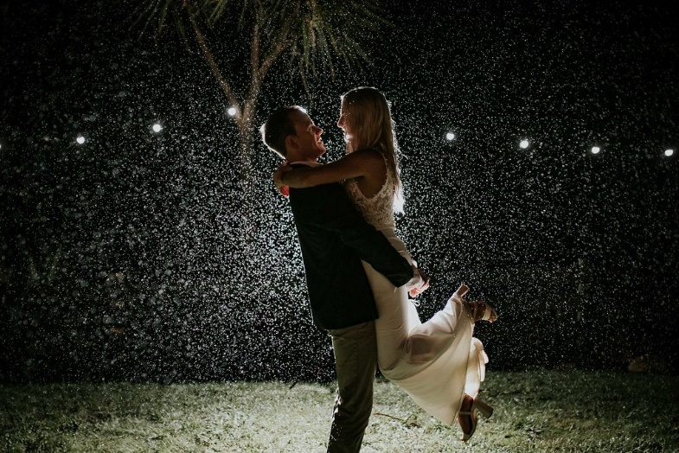
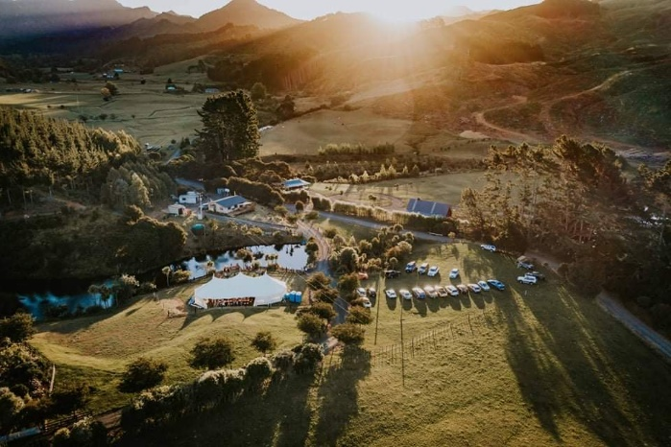

Upgrade Options
Need more space for dance floor, band, lounge furniture etc? – No Problem! - upgrade to a:
-16mtr x 13.5mtr Stretch Tent
for an additional $975.00

-21.2mtr x 9.7mtr Hampton Marquee
for an additional $1285.00

-18mtr x 9mtr Electron Marquee
for an additional $610.00

